Jahia Book
Chapter 3 - Planning

Jahia
9 route des Jeunes, CH-1227, Carouge Switzerland
http://www.jahia.com > The company web site http://www.jahia.net > The community web site

Version
This table records the versions of this document and their last updates
Version | Author | Date | Modifications
1.0 | Jonathan Coates | 2008-03-19 | Initial document
1.1 | Stéphanie Rouaud | 2008-07-11 | Add missing chapter

Summary
Page
Version 2
Summary 3
Specifications 4
Team work organization 5
Working with Jahia LTD 6
Content Design 7
Designing for performance 8
Case studies 8
Small Jahia site 8
Medium Jahia site 8
Large Jahia site 11
Scaling out the configuration 13
Fail-over configurations 13
Clustering 15

Specifications

Team work organization

Working with Jahia LTD

Content Design

Designing for performance

Case studies
In this section we will present three case studies that illustrate common Jahia deployment scenarios. We will talk about the typical use of such systems, the strength and limitations of each configuration, as well as the possibility to customize the deployment depending on the specific needs.

Small Jahia site
Jahia is quite able to provide a lot of functionality on a single server, and this configuration is aimed at smaller installations such as personal websites, small intranets, etc. In this configuration the Jahia installation doesn’t have any requirements for high-availability or high performance, and background tasks such as XML imports or indexing will directly influence the overall performance. The configuration will look something like the following diagram :
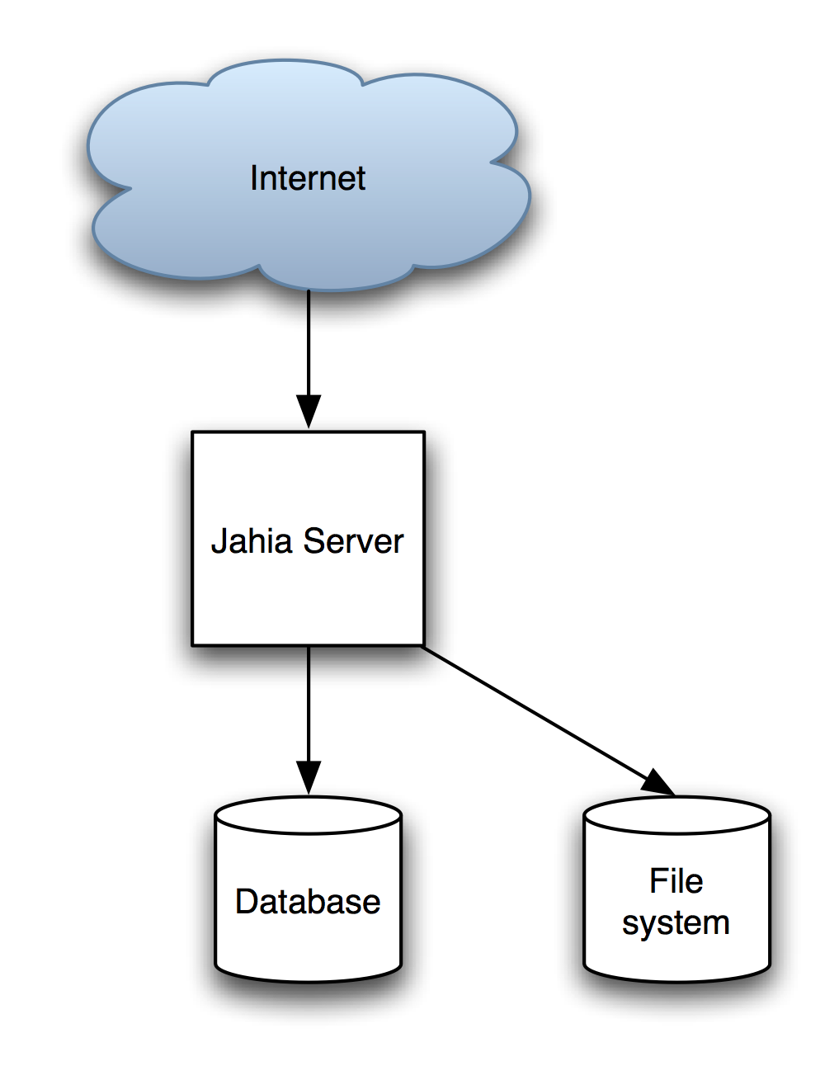
This means that the single Jahia server will handle all the caching, the browsing, the editing, the workflow processing, XML import, indexing and many other functions in an all-in-one server. User database is also completely handled by Jahia. Everything is stored in the database and the file-system (used for search indexes).

Medium Jahia site
The medium site case study is targeted towards high-volume mostly static sites. This doesn’t mean that they cannot contain elements of personalization or external data, but these will be built on top of Jahia internal output cache system, rather than by-passing it.
In order to achieve both high-performance and dynamic rendering of content and personalization, tasks are delegated to both the server and the client. Basically the server will serve cached HTML for the pages, and answer small HTTP requests coming from the client. The client will generate AJAX requests to the server, in order to render the dynamic part over the static cached pages. This allows Jahia to be able to serve pages really fast without having to regenerate full pages so often.
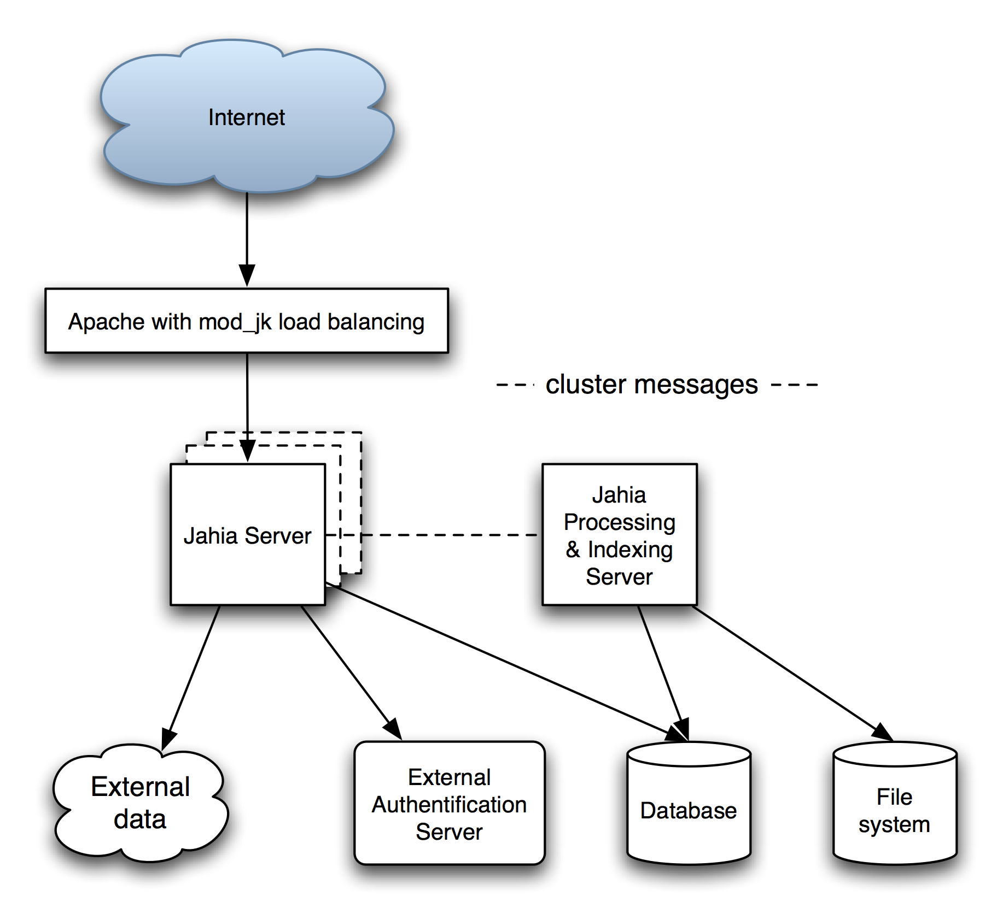
In the above illustration we can see the following elements :
- Apache Web server with mod_jk connector or any other hardware load balancer
- Jahia server, that may be installed on different cluster nodes
- A separate Jahia server dedicated to processing and indexing
- External data sources, such as syndicated content
- External custom authentification server (in this example non-LDAP)
- The database containing all the data managed by Jahia
- The file-system used to store search indexes
This case study includes the following features :
- Medium amount of pages (in the thousands of pages range)
- Large number of browsing users, very few editors, not a lot of personalization
- Integration of external data through client-side data aggregation
- Integration of an external authentification server that is implemented as a Jahia user provider
The Apache Web Server is installed on top of the complete stack so that it may perform both URL rewriting and load-balancing functions. The URL rewriting configuration is useful for exposing different URLs than the standard Jahia ones, and also if there is a desire to separate browsing and editing loads on separate servers. The load-balancing is based on a sticky-session mechanism because Jahia sessions must stay on the same server.
The integration of external data through client-side aggregation is important because it allows the page served by Jahia to come directly from the output (HTML) cache, and the external data is then included through Javascript that loads it from another server and modifies the page’s DOM (Document Object Model) to add the data as soon as it is loaded. Another possibility of doing aggregation on the client is to use IFrames to aggregate content. IFrames size is usually fixed, but it could be made flexible by using Javascript to automatically resize the IFrame to the content size (see http://www.dyn-web.com/dhtml/iframes/) .
User personalization is done the same way, basically upon login a cookie is inserted that is used by Javascript code to access external personalization data, or using the AJAX aggregation requests.
Another interesting part of this case study is that it integrates with an external authentification system that is non-LDAP. This is done through the custom development of Jahia user (and possibly group) providers, which is a pluggable interface. This of course is not a requirement and in most cases the LDAP provider will suffice as an authentification system, but we just wanted to illustrate the possibility to integrate with custom systems, as was done in this case study.
The clustering section of this case study allows to instantiate multiple times the Jahia server nodes, in order to handle more load. It would even be possible to extend on this setup to separate browsing and editing nodes, much in the same way as we will present it in the “large Jahia site” case study. A separate Jahia server node is dedicated for both processing and indexing workloads. This avoids loading the browsing and editing nodes with time-consuming operations such workflows, XML importing and indexing. It also allows the “simple” nodes to keep all available memory to support as many concurrent users as possible. In the above illustration we have illustrated the horizontal traffic that flows between the various Jahia server nodes, which is different from the request processing traffic that is presented vertically.

Large Jahia site
The large Jahia site case study is similar to an “all-you-can-eat” configuration of Jahia, and is possibly the “higher-end” Jahia installation. Such an environment is geared towards high-traffic and highly dynamic web site usage. It includes personalization, portlet usage, filters, sorters and searchers, separate browsing and editing servers, possibility to fail-over, LDAP server connection for user authentification, etc. The configuration we will present here can be summarized in the following diagram.
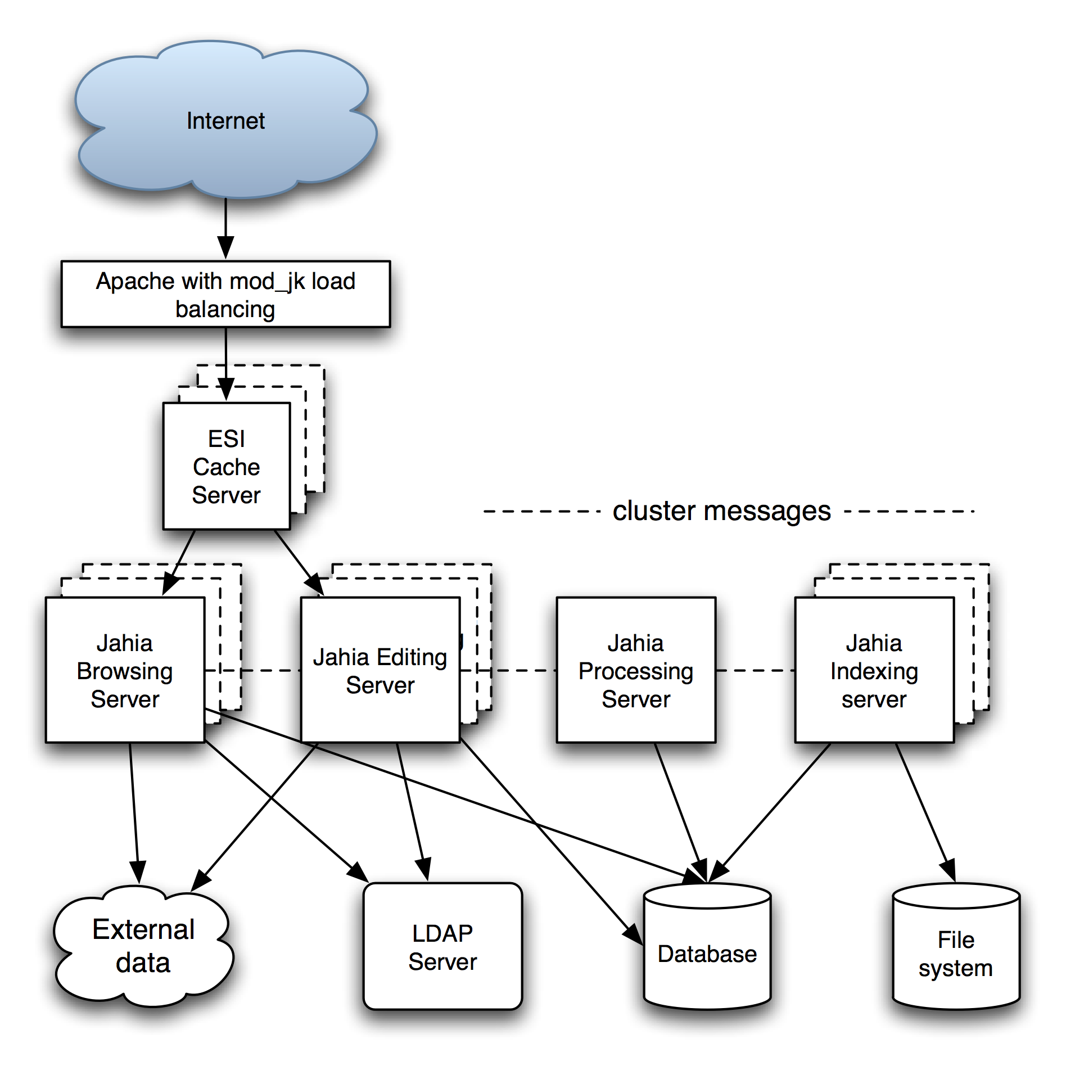
The above illustration is basically an expanded version of the medium site configuration. What is new is the introduction of the ESI front-end cache proxy server as well as the separation of Jahia servers into more granular specialized servers.
So basically the installation is composed of :
- A load-balancing Apache Web Server with a mod_rewrite and mod_jk configuration, or any other hardware load balancer. This server distributes the load over the various ESI cache servers, and is in charge of separating browsing and editing mode load. It is also possible to extend the configuration of the Apache configuration to support fail-over. More information about this type of deployment can be found in the below fail-over section.
- The ESI cache server is responsible of caching fragment of pages as well as the complete generated page. The idea here is to take advantage of fragment re-use across pages as well as sharing of fragments among similar groups of users, and to make it possible to mix both “static” and dynamic elements on a page, reducing performance impact to a minimum. So in this configuration the ESI server is also responsible of dispatching to the below Jahia servers, and balancing the load on them if desired.
- Jahia browsing nodes : these are basically Jahia nodes reserved for navigating the web site. The simplest way of doing this is to use Apache Web Server rewrite rules to choose which servers are dedicated to browsing, and which are dedicated to editing. This allows for fail-over configurations too, as we will see in more detail below.
- Jahia editing nodes : these nodes are dedicated to the workload generated by content editors.
- The Jahia processing server is in charge of handling all the long running jobs, except for indexing. This server has a requirement of being the only instance of this type, because of the potential corruption that could occur if two long-running jobs were running concurrently. In order to reliably perform jobs, they are serialized in the database, and should the server ever be shutdown and restarted, it will restart the jobs. Internally it uses the open-source Quartz enterprise scheduler (http://www.opensymphony.com/quartz/) that is a very reliable and flexible implementation of a job processing system.
- The Jahia indexing server is in charge of both the text extraction and the indexing of the content inserted into Jahia. The extraction of text from Adobe PDF or Microsoft Office is a heavy operation that uses up both CPU and memory, and therefore it is very important to separate this load on high-end installations that will contain large number of office files. This server can be replicated to scale out the configuration to better distribute load or to provide fail-over using mirrored file-systems.
- External data : the integration of external data in this case study is different from the medium site configuration, and can be performed with portlets for example. This is another reason why it is important to distribute browsing load on multiple machines, as they will also process the logic operations that the portlets contain. It is very important therefore to also make sure the portlets are very efficiently implemented, because in performance as in security the weakest link can bring the whole system down, so a portlet accessing a remote data server, if not down properly, could seriously hinder performance. Another way of integrating external data could be through the use of custom tag libraries integrated in Jahia templates. In this latter example, an integration with ESI fragment caching is also strongly recommended in order to benefit from the fragment optimizations that this server offers, in order to reduce the load on the Jahia server as well as the external data server.
- LDAP server : quite common in enterprise deployments is the integration of Jahia with a directory service. Jahia works well with various LDAP implementations such as Active Directory, OpenLDAP, Novell LDAP.
- Database : in this type of high-end configuration, the database choice and configuration is critical. As the number of requests can become very important, the proper dimensioning of the database server is critical. The chosen database should also be installed on powerful hardware, including lots of memory, and possibly also be clustered.

Scaling out the configuration
In the above illustration, you will notice that the ESI cache server, the Jahia browsing and editing nodes as well as the indexing server all have dashed boxes behind them. These represent the possibility to extend the load balancing by replicating these nodes multiple times in order to better distribute load as well as offer better availability.
Other important parts of the clustering configuration include of course the Apache Web Server that must be properly configured to distribute load, as well as the back-end servers. The LDAP server must be able to handle properly the larger amount of requests that will be generated by a growing number of nodes, and the external data server must also be able to scale out properly.
The database is really critical in terms of scaling out, and must be dimensioned properly. It is not the purpose of this document to explain how to achieve this, as each database implementation usually has good documentation on how to improve performance and scale out, but it should be remembered that when growing the installation for higher performance, the database is an extremely critical part of the equation.
For more information on clustering we refer you to the previously presented clustering description in this document.

Fail-over configurations
In the proposed configuration, it is possible to introduce fail-over installations, mostly by using the Apache web server with a powerful URL rewriting configuration that will test first the availability of the Jahia server before dispatching to them.
The really powerful mod_rewrite module of the Apache Web Server can be extended to do all sort of things using the RewriteMap configuration parameter that allows external programs to provide mapping. Here on the custom deployment you could develop (or integrate) a high-availability system that would check the status of the servers below, and provide a mapping function for the rewriting module. As of the time of writing though we do not provide such a script as part of our Jahia configuration, but it should just be noted that it is technically possible to achieve this type of install.
At the ESI cache server level, the cache server is capable of being connected to multiple Jahia server, and will modify its dispatching rules dynamically if a Jahia server becomes unavailable, and bring it back into the server pool once it is available again.
Jahia browsing nodes are configured actually as fully capable nodes, that include the possibility to perform edit loads, because of fail-over requirements. Basically the Apache Web Server is in charge of limiting the edit load to a subset of servers, checking if they are indeed available for editing, and if not the script should be capable of detecting the failure, and redirecting the editing load to the browsing nodes temporarily.
The fail-over configuration is more limited for the processing server, as it has inherent limitations because the long-running processes risk interfering with each other. Fortunately all the jobs are also stored in the database, so even if the server goes down and comes back up, the jobs will restart as expected. Therefore it is critical to have availability monitoring systems installed so that the downtime of the processing server is quickly detected and so that it may be restarted rapidly.
The indexing servers may be replicated to provider fail-over, but they also work the same way as the processing server, so fail-over is really dependent on quick failure detection and restart of the server, in order to guarantee system integrity. Also as they store their indexes on a file-system, it should also be setup so that a mirror file-system can takeover in case of failure. The configuration of such a setup is not in the scope of this document though, but let it be known that most modern operating systems offer solutions for problems like these.
The last important part of the fail-over configuration is the back-end system. The external data server must be also made reliably available, or at the minimum the front-end system accessing it must tolerate failure and possibly display a message asking to try again later. The LDAP server must be configured in a fault-tolerant configuration. Portlets and any back-end they may access should properly handle failure conditions, and possibly simply mark unavailability to the end-user if something goes wrong, until the system can be made available again. The most important one is the database, that must be really highly available, as any downtime could lead to serious data corruption. There are here fortunately many solutions specific to each database vendor, and it is usually not too much a problem of function but rather an issue of configuration and licensing cost.

Clustering

